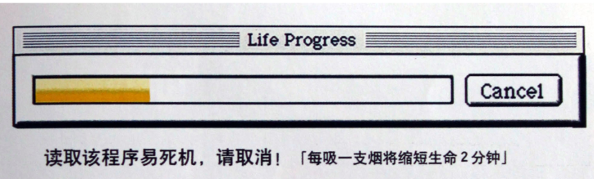

Purpose: Smoking is harmful to health.

Ways/Methods of advertising: Reading this program is easy to crash, please cancel it.Every cigarette smoked shortens your life by 2 minutes.The window of the computer which can be used to read the progress bar is similar to cigarettes, and the Cancel key is used to connect with the stagnation of smoking, so that the visual and logical relationship can be unified.

Values promoted: Every cigarette smoked shortens your life by 2 minutes.Reading this program is easy to crash, please cancel it.The advertisement appeal to people not to smoke, because smoking is not only harmful to their own health but also to the health of the people around them.

Originality/Creativity: The program of the computer used to read the progress bar is similar to cigarettes.The title of the window is replaced by Life Progress. The Cancel key is used to connect with the stagnation of smoking, so that the visual and logical relationship can be unified.The prompt message “Every cigarette smoked shortens your life by 2 minutes.Reading this program is easy to crash, please cancel it.”at the bottom of the program window shows us the harm of smoking.So for the health of our relatives,friends ,innocent strangers around us and ourselves ,we shouldn’t smoke.